EXPERIMENT: 09

NAME: KRISHNAKUMAR.R ROLL NO:240701275
Experiment: Form Validation using HTML, CSS, and JavaScript
Aim
To design a web form and validate user inputs (email and phone number) using JavaScript and Validator.js.

Objective
- To create a user-friendly form interface
- To apply styling using CSS
- To validate inputs using JavaScript
- To display error messages for invalid data

Requirements
- HTML (for structure)
- CSS (for styling)
- JavaScript (for validation)
- Validator.js library (for built-in validation functions)

Theory
Form validation ensures that the data entered by the user is correct and in the proper format before submission.
- Email validation checks whether the input follows a valid email format (e.g., abc@gmail.com)
- Phone validation ensures the number is valid using predefined rules
The Validator.js library simplifies validation by providing ready-made functions like:
- isEmail() → checks valid email
- isMobilePhone() → checks valid phone number

Procedure
- Create HTML Structure
  - Add a form with email and phone input fields
  - Include error message placeholders using <span>
- Apply CSS Styling
  - Center the form on the page
  - Add padding, colors, and spacing for better UI
- Add Validator.js Library
  - Include it using CDN
- Write JavaScript Code
  - Capture form submit event
  - Prevent default submission
  - Get user input values
  - Validate inputs using Validator.js
  - Display error messages if invalid
  - Show success message if valid

Program (Combined Code)
(Write the full code here — the one I already provided above)

Working Explanation
- When the user clicks Submit, the JavaScript function runs
- The form submission is stopped using e.preventDefault()
- Input values are checked:
  - If email is invalid → error message is shown
  - If phone is invalid → error message is shown
- If both are valid:
  - Data is printed in console
  - Success alert is displayed

Output
- Displays error messages for invalid inputs
- Accepts correct email and phone number
- Shows success message when inputs are valid

Result
The form validation system was successfully implemented using HTML, CSS, and JavaScript with Validator.js.

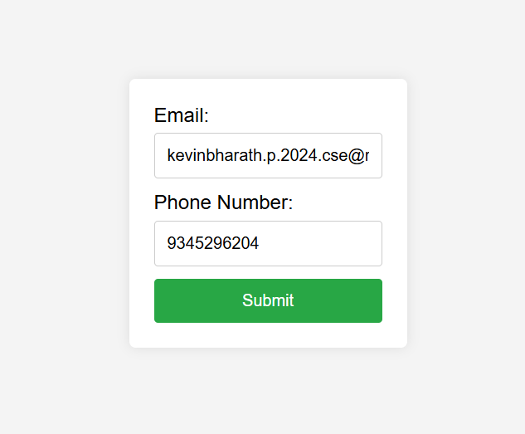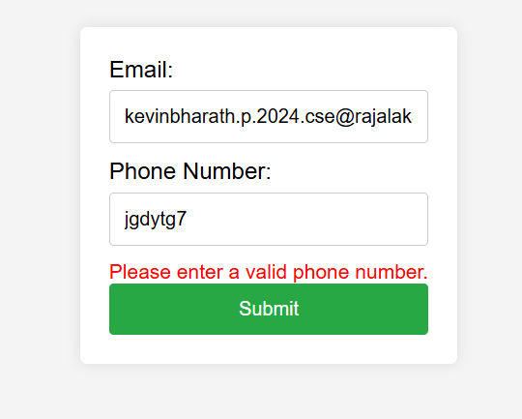

<!DOCTYPE html>
<html lang="en">
<head>
<meta charset="UTF-8">
<meta name="viewport" content="width=device-width, initial-scale=1.0">
<title>Form Validation</title>

<!-- CSS -->
<style>
body {
font-family: Arial, sans-serif;
background-color: #f4f4f4;
display: flex;
justify-content: center;
align-items: center;
height: 100vh;
margin: 0;
}

.container {
background-color: white;
padding: 20px;
border-radius: 5px;
box-shadow: 0 0 10px rgba(0, 0, 0, 0.1);
}

form {
display: flex;
flex-direction: column;
}

label {
margin-bottom: 5px;
}

input {
margin-bottom: 10px;
padding: 10px;
border: 1px solid #ccc;
border-radius: 3px;
}

button {
padding: 10px;
background-color: #28a745;
color: white;
border: none;
border-radius: 3px;
cursor: pointer;
}

button:hover {
background-color: #218838;
}

.error {
color: red;
font-size: 0.875em;
}
</style>
</head>

<body>

<div class="container">
<form id="myForm">
<label for="email">Email:</label>
<input type="email" id="email" name="email" required>
<span id="emailError" class="error"></span>

<label for="phone">Phone Number:</label>
<input type="text" id="phone" name="phone" required>
<span id="phoneError" class="error"></span>

<button type="submit">Submit</button>
</form>
</div>

<!-- Validator.js CDN -->
<script src="https://cdnjs.cloudflare.com/ajax/libs/validator/13.6.0/validator.min.js"></script>

<!-- JavaScript -->
<script>
document.getElementById('myForm').addEventListener('submit', function (e) {
e.preventDefault();

let email = document.getElementById('email').value;
let phone = document.getElementById('phone').value;

let emailError = document.getElementById('emailError');
let phoneError = document.getElementById('phoneError');

// Clear previous errors
emailError.textContent = '';
phoneError.textContent = '';

let isValid = true;

// Validate Email
if (!validator.isEmail(email)) {
emailError.textContent = 'Please enter a valid email address.';
isValid = false;
}

// Validate Phone
if (!validator.isMobilePhone(phone, 'any')) {
phoneError.textContent = 'Please enter a valid phone number.';
isValid = false;
}

// If valid
if (isValid) {
console.log("Email:", email);
console.log("Phone:", phone);
alert("Form submitted successfully!");
}
});
</script>

</body>
</html>

